Group Service Representative (GSR) Orientation
and Resources Handbook

Virginia District 10 (Loudoun)
2023-2024 Term
Welcome

Thank you for serving as your home group’s General Service Representative (GSR)! AA groups are the most important part of the AA service structure. Thus, you serve in the most important AA service position as your role is to be your group’s link to AA.

Your home group falls in Virginia District 10 (Loudoun) of the Virginia Area Conference (Area 71). Not only do you provide your group with information on what is happening in AA, you have an even bigger responsibility: You transmit your group’s ideas and opinions and are the group’s collective conscience at District meetings and at VAC Area Assemblies. As a GSR, you also have voting rights at VAC Area Assemblies on business matters.

As a GSR, you are the point of contact for group matters. You are also responsible for implementing the AA Traditions in your group meetings and activities. And you ensure that your group’s meetings are accurately listed on the applicable AA websites and in printed Where and When’s.

For an overview of a GSR’s responsibilities, please see the GSR pamphlet at: https://www.aa.org/sites/default/files/literature/assets/p-19_gsr.pdf.

Please note that it is also important for each group to elect an Alternate GSR. If the GSR is unavailable, this person would attend the District meetings and VAC Area Assemblies and act on behalf of the GSR.

When your GSR service rotation has come to an end, please contact dcm10@aavirginia.com. Each District has the responsibility to annually provide a list of current GSRs to the VAC/GSO.

Getting Started

Registering
As a new GSR, the Virginia District 10 DCM can get you registered with the AA General Service Office (GSO). Please email dcm10@aavirginia.org the following: Full name, mailing address, email, and phone number. The DCM will provide your contact information to the Virginia Area Committee who will then register you with the GSO which will mail you a New GSR Kit. The DCM will also email you an electronic version of the New GSR Kit.
District 10 Google Group Email
The DCM will add you to the D10 Google Group email distribution list - district10fob@googlegroups.com. It is important that you read each email carefully as it contains a lot of information for you to be successful as a GSR.
Please note that when you respond to an email sent to District 10, even if you just hit “Reply” versus “Reply All,” you are still emailing the entire group. If you wish to respond directly to the DCM, please edit the TO line to dcm10@aa.virginia.org.

Virginia District 10 (Loudoun)

The Virginia District 10 (Loudoun) Service Committee of AA is a service body whose primary purpose is to coordinate the efforts of all District 10 Groups in order to effectively carry the message of AA to the still suffering alcoholic and to the professionals who come in contact with alcoholics.

The District Committee encourages all AA Groups in the District to participate in the business of the District 10 and its efforts to cooperate with the Northern Virginia Intergroup (NVI), the Blue Ridge Area Intergroup (BRAI), the Virginia Area Committee (VAC), the General Services Office (GSO), and AA World Services (AAWS).

The Loudoun District Service Committee shall protect and respect the autonomy and the privilege of dissent of any AA group in the District. The District shall be ever mindful of the ideals expressed in the Twelve Steps, Twelve Traditions, the Twelve Concepts for World Service, and the AA Service Manual.

District 10 services the following: Ashburn, Bluemont, Leesburg, Lincoln, Lovettesville, Lucketts, Middleburg, Pine Grove, Purcellville, and Round Hill. Please note that while Sterling is in Loudoun County, it does not fall under District 10. Sterling is serviced by District 4 (Dulles). Aldie/Arcola is serviced by District 42 (Chantilly).

The District consists of officers, committee chairs, and GSRs. The terms of each officer position is two years. District 10 follows the VAC term and also elects new officers (DCM, Alternate DCM, Treasurer, Secretary) in October of an even year for commencement the following January of an odd year. We also follow the VAC committee chair structure. Service requirements for all positions can be found in the Virginia District 10 (Loudoun) Service Manual. Anyone AA member may attend the District meetings – they are not limited to those listed above.
District 10 Website and GSR Resources
New GSR Kit: Please download this kit and review that material. This is a GSR’s main source of information and you will be amazed at all that is included: https://www.aa.org/sites/default/files/literature/GSRLISTW%20GSRKitContents%20EN%200122.pdf
District Meetings: Come to the District meeting at 6:00 p.m. if you’d like to discuss GSR matters with the DCM before the meeting officially starts at 6:30 p.m.
District 10 Website: It is very important to familiarize yourself with the District 10 website: https://www.aaloudoundistrict10.org/. Under the Member Services tab is a wealth of information to assist GSRs. There is also information for group Treasurers.
Service Manuals: Please read the Virginia District 10 Service Manual which is also under the Member Services tab of our website as this applies to our District. You can also find the Virginia Area Committee (VAC) Service Manual as well as the AA Service Manual (combined with the Twelve Concepts for World Services) on our website.
AA Literature, Grapevine, Newsletter, Podcasts, Chips: Before the monthly District, the D10 Grapevine and Literature Chair sends out an email updating us on AA literature and Grapevine matters. Please read these emails carefully. Please be familiar with available AA literature. To support local, we encourage groups to order literature and chips from the Northern Virginia Intergroup. Also, your group can subscribe to the AA Grapevine magazine and to the AA Box 549 quarterly newsletter from the GSO. Please review the Resources tab on the AA website as it also provides links to podcasts, public service announcements, etc.

District Meetings
As a GSR, it is your responsibility to attend the monthly District meetings which are held the first Wednesday of every month from 6:30-7:30 at Holy Trinity Lutheran Church, 605 W Market Street, Leesburg, VA 20175. The DCM will be at the church at 6:00 to assist any GSR that wants to talk before the 6:30 meeting. Anyone in AA is welcome to attend the District meeting.

At the District meetings, the DCM provides the GSRs with information about what is happening in AA. It is your responsibility as a GSR to keep your groups informed about what is going on. This is not just a “forward” exercise. It requires an effort on the part of the GSR to actively keep up on AA matters and your group. In addition to the D10 website, there is further information at: https://aavirginia.org/ and https://www.aa.org/. And especially in the GSR Kit.

You are responsible for sharing your group’s opinions and concerns at the District meetings and letting your group know what was discussed - usually at your group’s business meeting or group conscience. If you are not able to discuss items with your groups, you serve as your group’s voice based on your knowledge of the group.
During the District meeting, each Committee Chair will also report on what is going on in their committees (see AA Service Structure below). Any GSR or AA member may volunteer to serve on a sub-committee of these committees.

Agendas, minutes from the previous meeting, and the monthly Treasurer’s Report are emailed by the District Officers before the monthly meeting.

Each month, we ask for a volunteer to present on one of the 12 Traditions and Concepts. During the two year term, we focus on a Concept each month during the first year and Tradition each month during the second year.

District Events
As a GSR, you are highly encouraged to attend and help garnish volunteers for our three District-sponsored events (Day of Sharing, Summer Picnic, and Winter Dinner/Dance), as well as an occasional event we co-sponsor with neighboring districts (usually a workshop and the annual Delegate Report-Back - see definition in next section). Each year, we seek a volunteer(s) to Chair these events under the overall guidance of the District’s Event Coordinator. Chairing a District event is a highly rewarding event and helps us stay in the “middle” of AA and meet lots of people.

Day of Sharing
Every year (2023 marks the 26th year), Virginia District 10 holds a Day of Sharing at Crossroads United Methodist Church in Ashburn, VA This annual event, typically held in February or March, draws in visitors from neighboring Districts and is widely attended. There are meetings all day, a pot-luck lunch, a speaker, 50/50 raffle, and a sobriety countdown. Tasks of the Chair include scheduling the church, organizing a committee and volunteers to help the Chair, vetting the speaker, ensuring adequate supplies, organizing the potluck (the District provides the main course), scheduling groups to lead meetings and the rooms to hold the meetings, obtaining 2 Big Books for the sobriety countdown, presenting the speak with a thank you token (gift), arranging for the music, set up and clean up, etc.

Summer Picnic
This is an event put on by the District, usually in June, at Franklin Park in Purcellville. The purpose is to have fun, eat lots of food, meet cool people, and listen to a great speaker! In the recent past, the event has been held on a Saturday in the Hillsboro Pavilion from 11:00 – 4:00. Tasks of the Chair include scheduling the pavilion (earlier in the year), organizing a committee and volunteers to help the Chair, vetting the speaker, organizing the pot-luck food (the District provides the main course), ensuring adequate supplies, scheduling the grill master shifts (cooks), arranging for the background music, 50/50 raffle, set up and clean up, etc.

Winter Dinner/Dance
This is an event put on by the District, usually around the beginning of December. The purpose is to have fun, eat lots of food, listen to a great speaker, and, of course – dance! Tasks of the Chair include scheduling the facility, organizing a committee and volunteers to help the Chair, vetting the speaker, organizing the pot-luck food (the District provides the main course), ensuring adequate supplies, decorating, arranging for the music, set up and clean up, etc.

Fall Workshop: Each year, it is the hope that a group(s) will sponsor a Fall Workshop. This can be done in partnership with a neighboring District. The District might also be asked to sponsor a VAC workshop which could take the place of this Fall Workshop with the assistance of the VAC.

District Participation in Local AA Intergroups
Virginia District 10 (Loudoun) participates in 2 separate and distinct Intergroups. These groups are not part of the official AA service structure but provide additional assistance to AA groups in their respective local area.
Blue Ridge Area Intergroup (BRAI): This intergroup provides services to Loudoun and several Districts west of us – AKA “Loudoun and West.” This intergroup holds an annual Gratitude Breakfast, prints a hard copy meeting Where and When for the area, maintains meeting information on their website, and provides a 24/7 Hotline: 800-835-6130. Their website is: https://blueridgeareaintergroup.org/. This intergroup does not maintain an office.

Northern Virginia Area Intergroup (NVI): This intergroup provides services to Loudoun and several Districts east of us – AKA “Loudoun and East.” This intergroup maintains an office in Fairfax Virginia, sells AA literature and chips to groups, maintains meeting information on their website, and provides a 24/7 Hotline: 703-293-9753. Their website is: https://nvintergroup.org/. NVI also has numerous committees which parallel the VAC structure as well as coordinates hospitals and institution commitments: https://nvintergroup.org/about/.

If your group is interested in keeping up on what’s going on in AA areas close to Loudoun, it can elect Intergroup Representatives to attend the BRAI and NVI Intergroup monthly meetings. District 10 has District Intergroup Representatives who attend both the District and 2 Intergroup meetings and relates information back and forth.

District 7th Tradition Contributions

Virginia District 10 (Loudoun). If your group would like to make a 7th Tradition contribution to the District, we welcome such! These funds help our District operate, allow us to hold our annual events, provide assistance to our Committees, and provide nominal financial assistance to GSRs to attend VAC Assemblies if funds are available. A separate “Pink Can” fund is also maintained to provide literature to Correctional facilities in our District.

Please make sure that checks are made out to “Virginia District 10” (not to AA or Loudoun). The mailing address is:

Virginia District 10
P.O. Box 6062
Leesburg, VA 22201
Other 7th Tradition Contributions: If a group wishes to make a 7th Tradition contribution to the:

(1) Northern Virginia Intergroup (NVI);
(2) the Blue Ridge Area Intergroup (BRAI);
(3) the Virginia Area Committee (VAC); and/or
(4) the AA General Services Office (GSO),

the addresses for those group can be found on our Virginia District 10 website.

***Please be sure to write both your group name and group number on all 7th Tradition checks.

AA Birthday Plan: The GSO has an AA Birthday Plan where individual members on their anniversaries, if so inclined, can contribute $1 for each year of sobriety. Here's the link to pass on to your groups: https://www.aa.org/aa-contributions-self-support. "They" say that if every AA member contributed to this program each year, AA would be fully funded!

District 10 Unique Situation

The Virginia District 10 (Loudoun) has a unique situation in that we have a Club in our location (Club 12). Club 12 is not AA. It is strictly a facility to which various recovery groups pay rent for space to hold their meetings (similar to groups holding meetings in a church). AA should never lend the name of AA to any outside organization. For GSRs hosting meetings at Club 12, you are responsible for ensuring that your home group is kept separate from the Club and that your group follows the 12 Traditions when conducting its meetings and events there. In addition, if your group hosts an event at Club 12 (e.g., an Alcothon), your group is responsible for doing everything related to that event and providing resources – no one on the Club 12 board may assist your group in these efforts. Club 12 is strictly a facility for which your group is renting space. Additionally, your group should not have Club 12 anywhere in its name – it is strictly the location of your meeting.

GSR Responsibility to Keep Meetings Up-to-Date

Each GSR is responsible for keeping its group’s meetings up-to-date with consistent information on relevant AA meeting websites (especially the D10 website) and in printed Where and Whens. After sending your updates to the contact information below, please follow up on these sites to make sure that the changes were made correctly.

Contact Loudoun District 10 to add, delete, or change meeting info: https://www.aaloudoundistrict10.org/meetings. There is a link to click to update your meeting information.
Contact the Virginia Area Committee (VAC) to add, delete, or change meeting info at https://aavirginia.org/vac-contacts/vac-web-site-contacts-help/. This also automatically updates the GSO Meeting App that many of us have on our phones.

Contact the Northern Virginia Intergroup (NVI) to add, delete, or change meeting info: https://nvintergroup.org/meetings/. Please note that at this time, NVI has suspended the printing of its hard copy Where and When.

Contact the Blue Ridge Area Intergroup to add, delete, or change meeting info on the BRAI website and in the printed Where & When: braiwandw@yahoo.com. Please note that only in-person meetings are printed in the BRAI hard copy Where & When - no virtual meeting information will be printed in the W&W.

12 Steps, Traditions, and Concepts
The 12 Steps of Alcoholics Anonymous are the structure to help us as individuals stay sober and help other alcoholics achieve sobriety: https://www.aa.org/the-twelve-steps.

The 12 Traditions of Alcoholics Anonymous are the structure to which each group should stay focused: https://www.aa.org/the-twelve-traditions. These are also discussed in the AA service Manual and the Twelve Traditions Illustrated pamphlet. GSRs should ensure that their groups follow the 12 Traditions in conducting its meetings and business.

The 12 Concepts of World Services are the glue that keeps AA as a whole together: https://www.aa.org/twelve-concepts-world-service-long-form. These are also discussed in the AA Service Manual Combined with the Twelve Concepts for World Services and the Twelve Concepts illustrated pamphlet.

GSRs should be familiar with the 12 Traditions and 12 Concepts.

AA Service Structure, Explained
The most important concept of the Service Structure is that it is an *UPSIDE-DOWN TRIANGLE.* Whereas in most organizations, power is concentrated at the top of a pyramid among a small number or even a single individual, in AA, the real power is in the groups themselves. The rest of the layers of the triangle involve passing the group conscience along from the groups to AA World Services (AAWS, which prints our literature), AA Grapevine/La Vina, and the General Service Board, all of which simply implement the will of the groups at the top of the triangle. Information then flows back up the triangle from AAWS, Grapevine, and the General Service Board through the Areas and Districts to the groups.
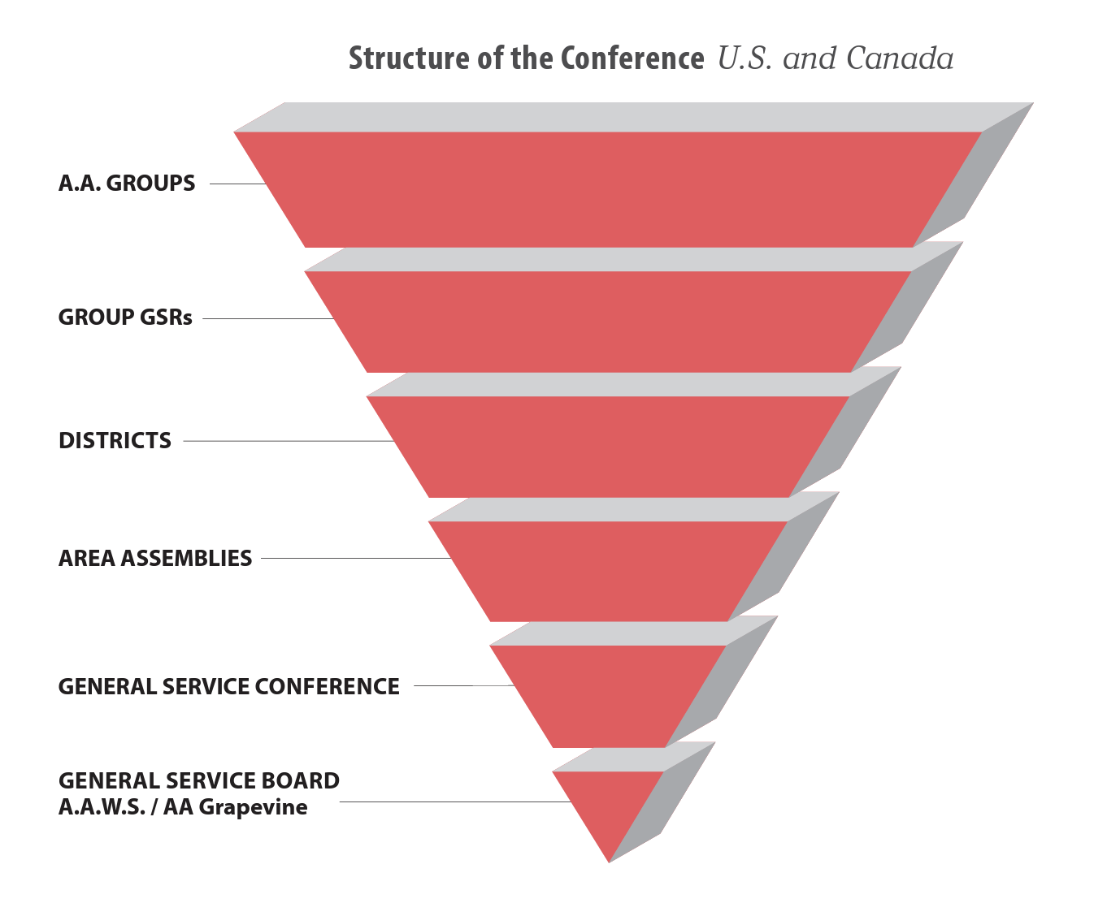
[Copied from the AA Service Manual]

GSR - General Service Representative, conduit from the home group to the District and Area, elected by a home group for a two-year term. You are also a voting member at the Virginia Area Committee Assemblies.

You, as GSR, transmit ideas and opinions, as well as facts. Through you, the group conscience becomes a part of “the collective conscience of our whole Fellowship.” - AA Service Manual (on the Virginia District 10 website). You would do so at the monthly District meetings, the VAC Spring Assembly, and the VAC Fall Assembly.

District - A group of all the GSRs and AA groups in a given geographic locality - in our case, Virginia District 10 (Loudoun).

DCM - District Committee Member, every two year term the District GSRs elect one member to represent the District on the committees at the Area level.
- DCMs attend the Spring and Fall Assemblies as well as the VAC/DCM Winter and Summer Meetings. No business is conducted at the Winter and Summer meetings – the purpose is to develop the agendas for the subsequent Spring/Fall Assemblies.
- They chair the District meetings and send out the agenda before the meeting.
- The AA Service Manual defines a DCM as “An experienced GSR elected by other GSRs to represent the groups of their district in area committee meetings and to coordinate service activities in the district.”
- However, both GSRs and DCMs are voting members of the Assembly, so when a GSR is elected to become DCM, their group needs to elect a new GSR to fill that role.

Virginia Area Assemblies (GSRs are voting members)
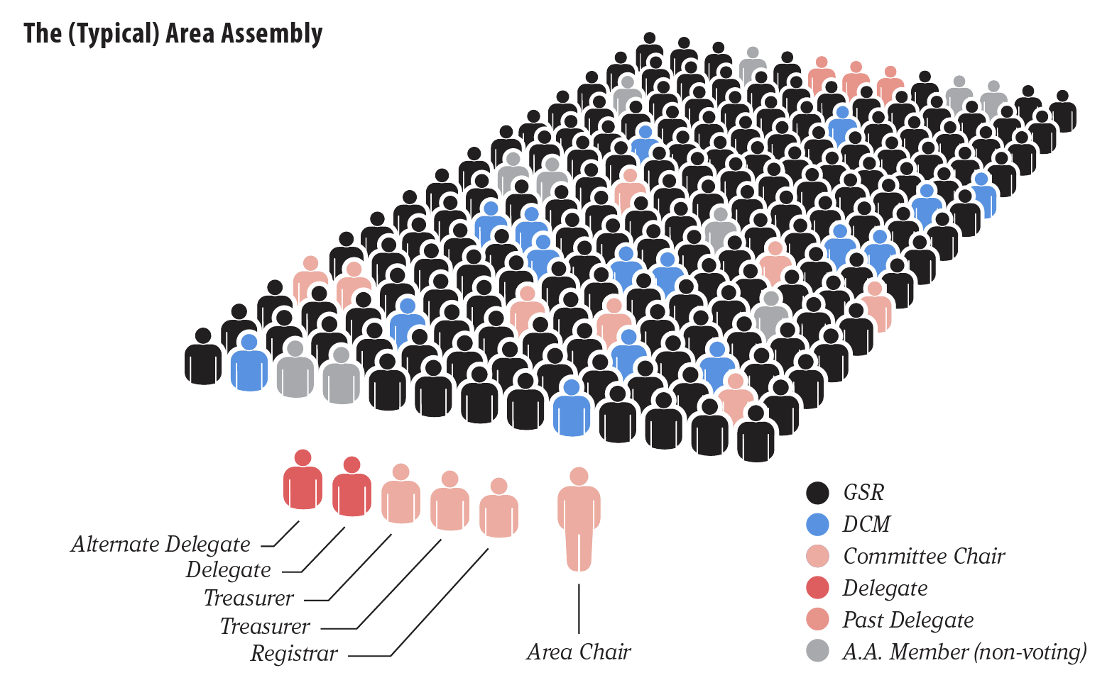
[Again, stolen from the AA Service Manual - in the Virginia Area Committee (VAC) there is only one Treasurer and a Secretary, and the Registrar is known as the Mailing List Coordinator]

As a GSR, you are *strongly encouraged* to attend the Spring and Fall Assemblies. This is where you pass on your group’s opinions on proposed changes to AA and you have a right to vote at this assembly! If you are unable to attend an Assembly, it is highly recommended that your group’s Alternate GSR attends. Also, if you are unable to discuss matters with your group prior to an Assembly, you will vote the conscience of your group based on your knowledge of the group. If you can only attend one Assembly, it is recommended that you attend the Spring one.

Area - A group of all the GSRs as well as the DCMs in every District in a given geographic area much larger than the District. In our case, this is the Virginia Area Committee (VAC) Panel 71.
VAC Committees — A Committee made up of 3 or 4 assigned DCMs and a chairperson appointed by the Area Chair. Districts with enough attendance at District meetings often form corresponding Committees at the District level. Virginia District 10 (Loudoun) follows the VAC committee structure.
- North America has 93 Areas across the US and Canada. For the most part, Areas are equal to US States or Canadian Provinces. However some places have a higher population of AA groups so some states have multiple Areas, while other Areas contain pieces of multiple States/Provinces.
- DCMs are assigned to a particular Committee on the Area level, this Committee corresponds to a Committee at the General Service Conference. During the 2023-2024 term, District 10 has been assigned to the Grapevine/Literature VAC Committee.
- VAC Committees are explained in the Virginia Area Committee Service Manual. District 10 also follows this structure as explained in the Virginia District 10 (Loudoun) Service Manual.

The current VAC Committees are:

  - Archives - collects, preserves and shares the history of AA and AA groups
  - Conventions - finds locations and coordinate conventions, working with the host area with planning
  - Corrections - seeks to carry the message of AA to incarcerated individuals
  - CPC - Cooperation with the Professional Community - informs professionals about AA
  - Finance & Budget - responsible for a sound fiscal policy for the area through self-support
  - Grapevine & Literature - informs all members on the availability and benefits of the Grapevine and other AA literature
  - Growth - responsible resolving problems and concerns that arise due to AA’s growth in the area
  - Cooperation with Intergroup - maintains the connections between the Districts and Intergroups, focusing on the local needs of AA
  - Public Information (PI) - works to convey the AA message to the general public
  - Treatment & Accessibilities - ensures that all can participate in AA
  - Website - responsible for maintaining the VAC website

VAC Assemblies - “At the heart of each area is the assembly meeting, where the democratic voice of our Fellowship expresses itself.” - AA Service Manual
- In Virginia, the full Assembly meets twice a year, in the Spring and in the Fall.
- In Winter and Summer, just the DCMs and Area Officers meet to set the agenda for the Assemblies and conduct committee business.

At the Spring Assembly, Conference Concerns, such as changes to AA literature or big AA policy changes, are discussed and voted on. [See Conference Concerns below] There are also workshops about topics like Safety in AA, Sponsorship, and so on. Many local GSRs have found them very interesting. In addition, two GSR Workshops are held. Between the Fall and Spring Assemblies, if your group can only afford one, the Spring Assembly is recommended as this is the Assembly where Conference Concerns are discussed for the Virginia Delegate to bring to the GSO conference in the summer where all state delegates vote on the changes. This is how change is effected in AA.

The Fall Assembly conducts business related to VAC Area 71 (e.g. changes to the website, local Archives information), and has workshops, including two GSR Workshops. Every other year, elections are held for VAC Officers, Delegate and Alternate Delegate.

The Assemblies are held at various locations throughout Virginia. Ask your group if they will reimburse your expenses, and even if they don't, please consider going. Sometimes GSRs agree to share hotel rooms to keep costs down. Sometimes the Assemblies are in the Northern Virginia area and do not require travel or hotel costs. Virginia District 10 (Loudoun) may be able to provide nominal financial assistance if groups cannot afford to entirely fund a GSR’s attendance and District funds are available.

There is no charge to register for any Assembly. The costs are hotel (Friday and Saturday night), gas, and food. Some Assemblies have generous hospitality suits which can keep food costs down (e.g., some hospitality suits have pizza, sandwiches, lunch/dinner type food).

All the details on the date, hotel etc. are here: https://aavirginia.org/events/. Each group would fund the GSR’s attendance at the Assemblies. Please keep your group informed of the estimated amount of funds needed. The DCM will provide you with the Spring and Fall Assembly registration, costs, and other information as received from the VAC.

Delegate - The Virginia Area Assembly elects one member to become the Delegate to the General Service Conference.

General Service Conference -
This is the annual meeting of Conference delegates each spring in New York (late April). After each Spring Assembly, the VAC Delegate attends this conference to pass on the 47 Virginia Districts’ opinions (collective conscience) on the Conference Concerns and vote on such.

- At the annual Conference, matters of importance to AA as a whole are considered and discussed.
- Area delegates make up at least two-thirds of the Conference body.
- Other members making up the General Service Conference are 21 trustees, both nonalcoholic (Class A) and alcoholic (Class B); directors of AA World Services and Grapevine; and AA staff at G.S.O., Grapevine and La Viña, bringing the total number of Conference members to approximately 135.

Conference Concerns
“Every AA member has a voice in the Fellowship’s present and future — and AA’s welfare is central to the agenda of every General Service Conference.” - AA Service Manual.”

The final agenda for any Conference consists of items (recommended changes to AA) suggested by individual A.A. members, groups, delegates, trustees, area assemblies, area committee members, and directors and staff members of A.A.W.S. and the Grapevine. The Conference considers matters of policy for A.A. as a whole, and there are tried-and-true procedures for placing an item on the agenda in the most effective way or, when the suggestion does not concern overall policy, for routing it to the most appropriate part of the service structure.

At the VAC Spring Assembly, Conference Concerns are discussed so that the Virginia Delegate can then bring the collective conscience of the AA groups in Virginia to the General Service Conference where the Conference Concerns are voted on. This is how change is effected in AA and you, as a GSR in the AA Service Structure, play the most important part.

Agenda Items (Conference Concerns) - Path to the General Services Conference

- Agenda Items are submitted by Members, Districts, Areas, Delegates, Trustees or Board Members.
- Agenda Items are received and assigned to a corresponding Trustee’s Committee
- Usually the Trustee’s Committee determines the appropriate route for the item - it can be a workshop, presentation subject, proposal or Committee Concern.

Agenda Items (Conference Concerns) – Timeline (approximate)
September 15: Proposed Agenda Items are due. Anyone in AA can propose a change to AA to the GSO.
December 15: Preliminary Conference Agenda Items are released by the GSO.
February 15: Final Conference Agenda Items are released by the GSO to our VAC delegate, who provides them, along with the background material to DCMs and Area Committee Chairs.
February 28: DCMs forward this information to the GSRs in their district. GSRs present these Agenda Items to their groups during a business meeting or group conscience - can be a regular meeting or one called specifically to discuss the Conference Concerns. If a GSR is unable to meet with their group before the Spring Assembly, the GSR would discuss/vote on concerns and business items based on his/her knowledge of the home group.
April 1: Spring Assembly – Discuss Conference Concerns

Spring Assembly - Friday Night: VAC Committee meetings are held where the assigned DCMs present on specific Conference Concerns impacting their Committee’s area of focus (e.g., Treatment, Corrections, etc.) and discuss/provide a “sense of the committee” (not a vote, but the process is the same). Anyone can attend these meetings. There is also a GSR workshop on Friday nights as well as a late night AA meeting.

Spring Assembly - Saturday: VAC Committee Chairs present the Conference Concerns to the Assembly as a whole as well as an abridged version of the discussion and the sense of the committee.

- At this point anyone in attendance may go to the microphone and speak on the subject - usually briefly, as there are many Concerns and many people to hear from
- When discussion has ended, those in attendance provide a “sense of the Area” for the Delegate to take to New York
- The GSRs and DCMs (voting members) also have an opportunity to vote in VAC business matters.
- Also on this day, participants will have an opportunity to attend 1 of 4 workshops (which are decided upon at the VAC/DCM Winter Meeting). And another GSR Workshop is held this day as well as a late night AA meeting.
Spring Assembly – Sunday Morning: There is an early morning AA meeting. Then a workshop where participants can attend 1 of 4 workshops. There is an Ask-It Basket session where many GSRs have questions. There is also a GSR Sharing session where GSRs throughout Virginia can discuss their experiences at the Assembly and what is going on in their home groups.

Types of Agenda Items (Conference Concerns) discussed at the Spring Assembly

There are several types of Conference Concerns on the Agendas for each of the VAC Committees. The first word of the item will indicate which type of item it is. The types are:

- Review - This usually means a Conference Concern has already been through the Conference and Trustee process and is a project in motion (a pamphlet or book, for example). We do not have the option to say, "No, don't review." It's a work already in progress.
- Discuss – This Conference Concern will come up for discussion in the Conference-assigned committee, but not necessarily make it out of committee to the floor of this year's Conference, although this has happened in the past.
- Consider - These Conference Concerns have more potential to make it out of committee to the Conference floor for a vote.

General Services Conference

Late April: At the General Services Conference in New York, our Virginia Delegate takes the sense of the Virginia Districts to the Conference and votes with the Districts’ opinions in mind. This is why it is very important for GSRs to attend the Spring Assembly.

After the General Services Conference
Delegate Report-Back - After the Conference meeting our delegate “reports back” to their area about what happened at the Conference.

- Our delegate tries to brief each District, but in order to cut down on the crazy amount of work/travel/speaking that would be required to brief 45+ Districts, the Northern Virginia area tries to combine our report-backs. (In District 10, we usually combine with District 4 - Dulles.)
- Each GSR, having attended the report-back and having had the opportunity to hear from and ask questions of their delegate, is then responsible for informing their group on the Conference outcomes.

Advisory Actions - Items approved by a two-thirds majority of Conference members become Conference Advisory Actions; they are referred to the trustees of the General Service Board for implementation.

- Advisory Actions are not binding, meaning they can be overturned, repealed, etc. by a future Conference.

Miscellaneous Information

GLOSSARY OF ACRONYMS:
CFC – Correctional Facilities Committee
CPC – Cooperation with the Professional Community
DCM – District Committee Member
ADCM – Alternate DCM
GSR - General Service Representative
PI – Public Information
VAC – Virginia Area Committee
BRAI – Blue Ridge Area Intergroup
NVI – Northern Virginia Intergroup
GSO – General Service Office
AAWS – AA World Service

Last updated January 2023

Acknowledgement: Thank you to Virginia District 2 (Arlington) for providing their GSR Orientation package which served as a framework for this District 10 GSR Handbook!

