VOLUNTEERS NEEDED!
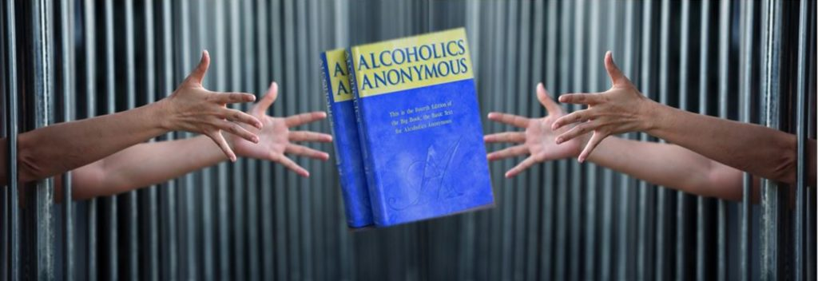

The District 10 Correctional Facilities Committee
is looking for AA members interested
in carrying the message behind the walls at the
Loudoun County Adult Detention Center.

Volunteers should have a minimum of 1 year of sobriety. Commitment is for one meeting per month
(Thursdays @ 7 p.m.)
Background checks are necessary.
For more information
Please call John J
443-676-4340
HELP MAKE SURE THE MESSAGE IS HEARD
BY THOSE BEHIND THE WALLS.

